**Advanced Database System (Lab)**

**PRN:** 2122000567

**Name:** Sujay Sanjay Gangan

**Roll No.:** B35

**Experiment No.:** 02

**Problem Statement 1:**

**Create a super type person**

Person: attributes -->fname (first name), lname (last name) dob (date of birth)

Methods -->FullName(to return full name), OnDate(return dob)

**Create a sub type EmpObj** which will inherit the person type attributes and methods.

Empobj (inherits Person): attributes --> job, sal, da(allowance), doj(date of joining)

Methods -- > Earn (return earning), OnDate(overriding return doj)

**Problem Statement 2:**

**Implementing Table Inheritance in SQL Server**

The following entities in a "School" database:

Super type: People

Sub types:

* Students
* Teachers
* Parents

Each of those entities has many of the same attributes, such as first name, last name, middle name, and birth date. Yet, we must separate them into multiple tables because we need to store and track different data for students, teachers and parents: students have grades and classes and parents; teachers have classes taught, skills, employment information, and so on.

**PROBLEM STATEMENT 1:**

CREATE TYPE PersonType AS OBJECT

(

fname VARCHAR(50),

lname VARCHAR(50),

dob DATE,

MEMBER FUNCTION FullName

RETURN VARCHAR,

MEMBER FUNCTION OnDate

RETURN DATE

) NOT FINAL;

CREATE OR REPLACE TYPE BODY personType AS

MEMBER FUNCTION FullName

RETURN VARCHAR IS

BEGIN

RETURN fname || ' ' || lname;

END FullName;

MEMBER FUNCTION OnDate

RETURN DATE IS

BEGIN

RETURN dob;

END OnDate;

END;

--**Creating Employee Table**

CREATE TABLE EMPLOYEES OF EMPOBJTYPE;

INSERT INTO EMPLOYEES VALUES ('Ravi', 'Shastri', TO_DATE('12-05-90',

'DD-MM-YY'), 1, 'Software Engineer', 60000, 5000, TO_DATE('15-06-20', 'DD-MM-YY'));

INSERT INTO EMPLOYEES VALUES ('Suman', 'Singh', TO_DATE('09-10-92',

'DD-MM-YY'), 2, 'Data Analyst', 55000, 4500, TO_DATE('22-03-19', 'DD-MM-YY'));

INSERT INTO EMPLOYEES VALUES ('Amit', 'Shah', TO_DATE('20-07-85',

'DD-MM-YY'), 3, 'Project Manager', 75000, 7000, TO_DATE('05-11-17', 'DD-MM-YY'));

INSERT INTO EMPLOYEES VALUES ('Pooja', 'Kulkarni', TO_DATE('15-12-94',

'DD-MM-YY'), 4, 'HR Manager', 58000, 4800, TO_DATE('30-09-21', 'DD-MM-YY'));

INSERT INTO EMPLOYEES VALUES ('Rahul', 'Mehra', TO_DATE('14-03-88',

'DD-MM-YY'), 5, 'DevOps Engineer', 62000, 5200, TO_DATE('19-01-18', 'DD-MM-YY'));

--**Query:**

--**Display employee Id, Employee Full Name, Employee Date of joining,**

**--Employee Date of Birth and Employee Earning for all employees.**

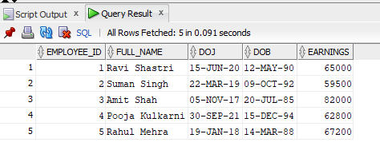SELECT

e.employee_id,

e.FullName() AS FULL_NAME,

e.OnDate() AS DOJ,

e.dob AS DOB,

e.Earn() AS EARNINGS

FROM EMPLOYEES e;

**PROBLEM STATEMENT 2:**

CREATE OR REPLACE TYPE Person AS OBJECT (

fname VARCHAR(20),

lname VARCHAR(20),

address VARCHAR(30) ) NOT FINAL;

CREATE OR REPLACE TYPE Student UNDER Person (

prn VARCHAR(20),

dept VARCHAR(20) );

CREATE OR REPLACE TYPE Teacher UNDER Person (

tid VARCHAR(20),

dept VARCHAR(20),

salary INT );

CREATE OR REPLACE TYPE Parent UNDER Person (

contactNum VARCHAR(20),

occupation VARCHAR(20) );

CREATE TABLE Students OF Student;

CREATE TABLE Teachers OF Teacher;

CREATE TABLE Parents OF Parent;

-- **Insert data into Students table**

INSERT INTO Students VALUES ('Rahul', 'Sharma', '123, Sector 14, Noida', 'PRN2021001', 'CSE');

INSERT INTO Students VALUES ('Anita', 'Verma', '456, Sector 15, Delhi', 'PRN2021002', 'MECH');

INSERT INTO Students VALUES ('Ravi', 'Kumar', '789, Sector 16, Gurgaon', 'PRN2021003', 'EE');

INSERT INTO Students VALUES ('Pooja', 'Mehta', '321, Sector 17, Faridabad', 'PRN2021004', 'CVL');

INSERT INTO Students VALUES ('Neha', 'Singh', '654, Sector 18, Ghaziabad', 'PRN2021005', 'IT');

SELECT * FROM Students;

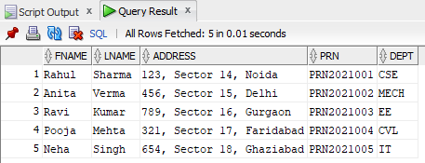

-- **Insert data into Teachers table**

INSERT INTO Teachers VALUES ('Vijay', 'Patel', '12, Main Street, Ahmedabad', 'TID001', 'CSE', 50000);

INSERT INTO Teachers VALUES ('Sunita', 'Desai', '34, Market Road, Mumbai', 'TID002', 'MECH', 55000);

INSERT INTO Teachers VALUES ('Ajay', 'Reddy', '56, High Road, Bangalore', 'TID003', 'EE', 52000);

INSERT INTO Teachers VALUES ('Kiran', 'Bansal', '78, Park Lane, Pune', 'TID004', 'CVL', 53000);

INSERT INTO Teachers VALUES ('Meena', 'Nair', '90, College Avenue, Chennai', 'TID005', 'IT', 60000);

SELECT * FROM Teachers;

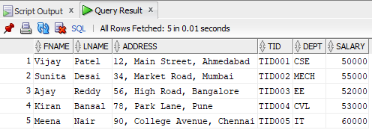

-- **Insert data into Parents table**

INSERT INTO Parents VALUES ('Raj', 'Singh', '11, Hilltop, Jaipur', '9876543210', 'Engineer');

INSERT INTO Parents VALUES ('Suman', 'Gupta', '22, Riverbank, Kolkata', '8765432109', 'Doctor');

INSERT INTO Parents VALUES ('Arvind', 'Sharma', '33, Green Valley, Hyderabad', '7654321098', 'Businessman');

INSERT INTO Parents VALUES ('Deepa', 'Iyer', '44, Oceanview, Surat', '6543210987', 'Teacher');

INSERT INTO Parents VALUES ('Ramesh', 'Bhat', '55, City Center, Cochin', '5432109876', 'Lawyer');

SELECT * FROM Parents;

